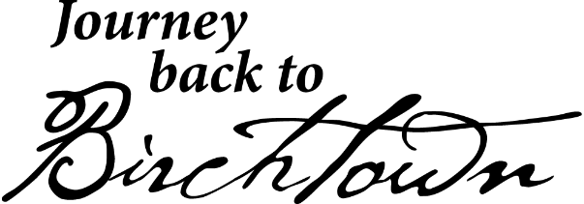

PUBLIC SERVICE ANNOUNCEMENT
Schedule of Events June 5-6, 2015
June 5th
- 4:30 pm - On June 5 The Black Loyalist Heritage Centre will host CTV News at 5 on site – there will be performances and interviews with guests on site and we encourage residents to come out and be part of the show as CTV news at 5 comes for the first ever remote show in the area! People are encouraged to come for 4:30 – seating will be available.
- 7pm - Lawrence Hill, renowned author of the Book of Negroes, hosts a sold out intimate reading and Q&A at 7pm at the centre.
June 6th

- 9am – 2pm – FREE Tours of the Centre. The centre will be closed during the stage presentation.
- 9am - Shuttle service begins in Shelburne – see map of route for pickup locations and recommended parking areas.
- 12:30 – Dr. John W. Franklin of the Smithsonian
- 1:30 pm – Opening Procession – Public is invited and encouraged to participate in the procession from the sacred burial ground to the stage area – the procession will include community leaders and featured musicians and artists. This will be a short walk approximately 5 minutes. Seating near the stage area will be limited the public is encouraged to take folding or portable chairs where possible and dress for the weather as this is a rain or shine event.
- 2 pm – Journey Back to Birchtown begins – with an opening by Dr. Elizabeth Cromwell, Deborah Hill, Lawrence Hill, the Hon. Gerald Keddy and the Hon., Tony Ince.
- 2:10 pm – The Journey Back to Birchtown begins featuring performances by African Nova Scotian artists and a multi-media stage presentation. Performers include Juno award-winner JRDN, Jeremiah Sparks, Dutch Robinson, Shelley Hamilton, Cyndi Cain, the Nova Scotia Mass Choir, the Sierra Leone dancers, Shauntay Grant, Hillcrest Academy Djembe Group and many more.
- 9pm-1am - A celebratory dance, featuring the Carson Downey Band, will be held at the Shelburne Community Centre from 9pm to 1am for patrons 19+. Tickets are $10/person. Cash bar will be available.
NOTE:
- The event is rain or shine, please dress accordingly.
- Seating is limited. We encourage visitors to bring folding chairs.
- Due to limited parking in Birchtown, we also encourage visitors to use the FREE shuttle bus service transporting visitors from Shelburne to Birchtown every half hour. The shuttle will pick up and drop off passengers at the Shelburne Community Centre parking lot. Shuttle service available on June 6th ONLY
- The Birchtown Community Centre will be hosting a BBQ lunch. Menu will include hamburgers, hotdogs, sausages and potato salad. We encourage people to bring small bills as there is no ATM on site.
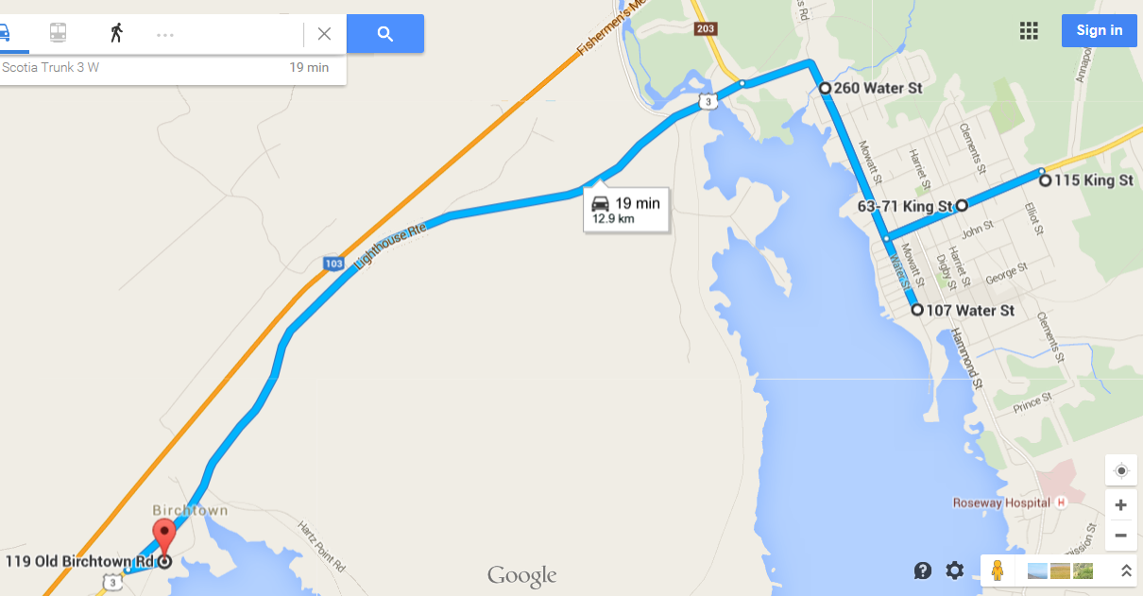
FREE Shuttle Bus Route ONLY available JUNE 6th
Stop 1- MacKenzie Cottages (park at library parking lot) and Wildwood Motel 260 Water St.
Stop 2- Coopers Inn - 36 Dock Street Pickup on Dock at Mason
Stop 3- Yacht Club Parking Lot - 107 Water St
Stop 4- Fire Hall and Arena (parking on John St. is encouraged) - 63 King St.
Stop 5- Shelburne Mall - 115 King St.

Returns to Birchtown - 119 Old Birchtown Road - every 30 minutes until 5:30 pm

Link to Google Map:
https://goo.gl/maps/UHTTD

